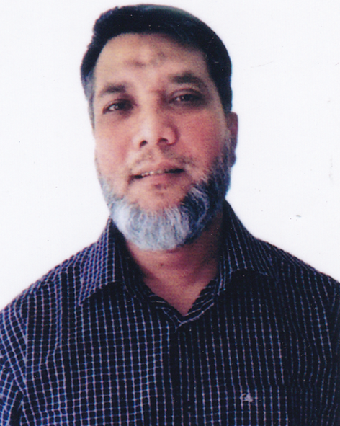
Resume of
MD. HEFZUR RAHMAN

CONTACT ADDRESS

House-25, Road-04, Block-B,
Nobodoy Housing, Mohammadpur,
Dhaka-1207.
Cell: 01816-216765

E-mail: hefzurrahmanatik@gmail.com

GENERAL INFORMATION:

Preferred Category : Accounts Finance.
Preferred level of position : Management Level
Highest Qualification : ICMAB (Inter Complete), M.A (Philosophy).
Currently available for : Full time.

CAREER MISSION:

Immediate:
Mid level Management position particularly in the area of Finance, Accounts, Treasury Management, having a career advancement opportunity in a multinational or reputed company or a group of companies environment on development & donor agencies.

Long Term:
Overall responsibility of Finance, Accounts as well as administrative management in any reputed organization.

- PROFESSIONAL ATTAINMENT

I successfully completed ICMAB (Inter) from the Institute of Cost and Management Accountants of Bangladesh (ICMAB) bearing Registration No. 21297 and completed 1400 Marks plus continuing study my Professional Course. I have also passed the subject Level-IV 404.Taxation.

- EDUCATIONAL QUALIFICATION

ICMAB Professional Level-III Intermediate
Grade : Inter Qualified
Institution : The Institute of Cost and Management Accountants of Bangladesh (ICMAB)

Master of Arts
Year of passing : 1991
Result : Second Class
Institution : University of Chittagong

Bachelor of Arts
Year of passing : 1989
Result : Third Class
Institution : University of Chittagong

Higher Secondary Certificate (H.S.C)
Year of passing :1986
Result : Second Division
Group : Science
Institution : Bikrampur K.B College

Secondary School Certificate (S.S.C)
Year of passing : 1984
Result : First Division
Group : Science
Institution : N.G.F.F High School
- FIELDS OF STUDY ( ICMAB)

- Financial Accounting-I | - Business Laws
- Fundamentals of Management and Production Technology | - Cost Accounting-II
- Business Mathematics and Statistics | - Management Accounting-I
- Business Communication and Report Writing | - Information Technology Management-I
- Financial Accounting-II | - Corporate Laws and Secretarial Practice
- Cost Accounting-1 | - Taxation
- Managerial Economics
- Information Technology Management-I

    - Job Experience:

Total Year of Experience:
25.1 years experience in Accounts & Administration Department as a Manager in various Manufacturing concern such as Youth Spinning Mills Ltd. , Amber Cotton Mills Ltd., Best Way Group etc.

COMPUTER SKILL

- Basic Office package (MS-Word, MS-Excel, PowerPoint)
- Efficient in Internet based communications.
- Accounting Package: Tally, ERP

- PERSONAL PROFILE

Father’s Name : Late Fazlur Rahman
Mother’s Name : Begum Zayeda Rahman
Date of Birth : 25 Nov 1968
Religion : Islam
Marital Status : Married
Nationality : Bangladeshi
Blood Group : B+
Mailing Address : House-25, Road-04, Block-B, Nobodoy Housing,
Mohammadpur, Dhaka-1207.

Permanent Address : House-25, Road-04, Block-B, Nobodoy Housing,
Mohammadpur, Dhaka-1207.
REFERENCE
- Md. Nurul Islam  Executive Director  Amber Cotton Mills Ltd.  Bangla Bazar, Gazipur  Cell: 01730-796840  01816-179335 | 2. Mir Mahbubul Bari, FCMA  Cost Consultant  Cell: 01730-089007
- DECLARATION

I declare that all the information presented here is true to my knowledge. If required and where applicable these documents can be supported by appropriate authentic certificates/papers.

__________________
Md. Hefzur Rahman

